

AMITY UNIVERSITY,BENGALURU

SOURCE CODE MANAGEMENT

Submitted To: Submitted By:

Dr.MONIT KAPOOR SIR SUMAYA IQBAL

Submission date: Eno:A866175124039

31-05-2025 Course slot: L5+6

Course: Btech-CSE(AI ML,2nd sem)

Index

Session -1:Basic linux-commands taught in git bash 1

Session-02: Installation and configuration of gitbash and GitHub2

Session-03 Introduction to GitHub and configuration into gitbash

Session-04 Creating branches and pushing into it (was a part of CA-1)

Session-05: Merging two branches with and without conflicts and graphing all of them

Session-06: Pull Requests and close in Github

session-07: GITHUB PROJECT.

# Session -1:Basic linux-commands taught in git bash :

1. mkdir-To create a new file or directory
2. Rndir-To delete a new directory
3. Cat-to view the current file
4. Pwd-To know which file we stand on (path)
5. Ls- to get the list of directories in the system
6. cp- copying files or directories to another
7. ping- connecting to a network host
8. mv- moving files or directories
9. rn-removing files
10. vi/nano- creating new files
11. touch-fetching empty files
12. ls -ah files in current directory

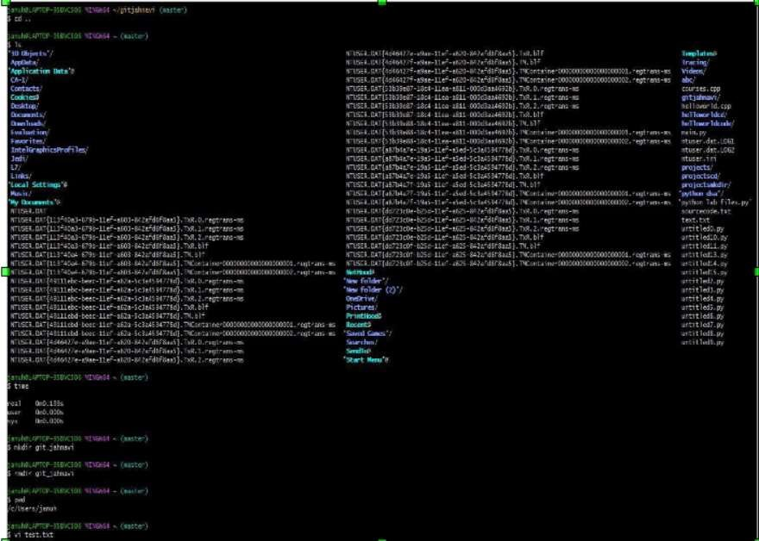

# Session-02: Installation and configuration of gitbash and GitHub

1. Download Git for Windows

Navigate to the official Git website and download the installer for Windows.

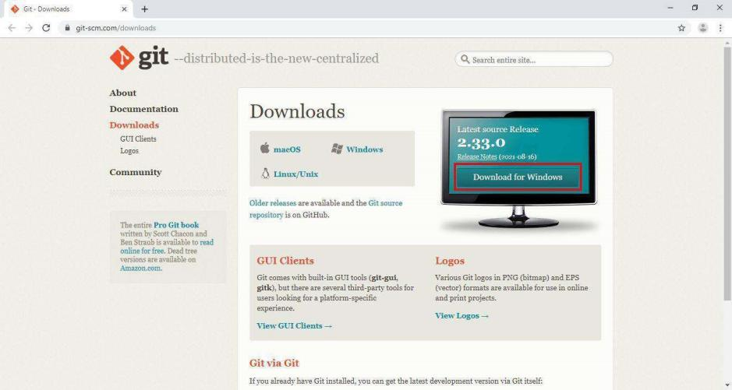

1. License Agreement

Upon running the installer, you'll be presented with the GNU General Public License. Accept the agreement to proceed.

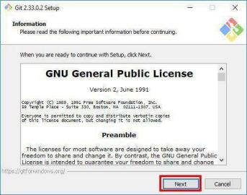

1. Select Installation Folder

Choose the directory where Git will be installed. The default path is usually sufficient.

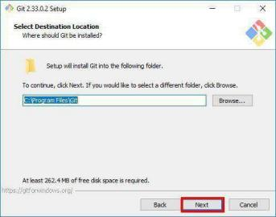

1. Select Components

Select the components you wish to install. It's recommended to leave the default selections unless you have specific requirements.

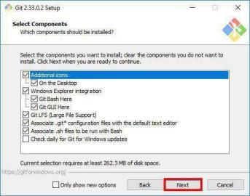

1. Choose Start Menu Folder

Decide on the Start Menu folder name where Git shortcuts will be placed.

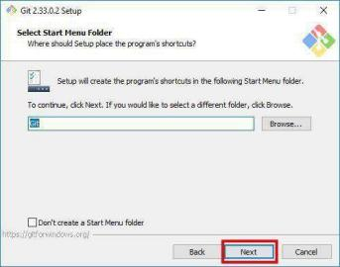

1. Choosing the Default Editor

Select the default text editor for Git. Visual Studio Code is a popular choice.

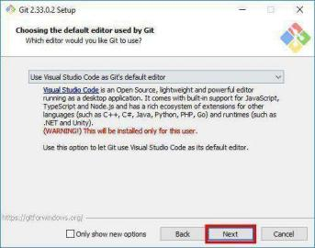

1. Adjusting the Name of the Initial Branch

Set the default branch name for new repositories. "main" is commonly used.

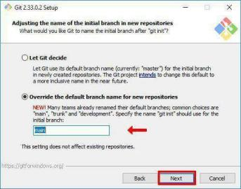

1. Adjusting Your PATH Environment

Choose how Git will be integrated into your system's PATH. The recommended option allows Git to be used from the command line and third-party software.

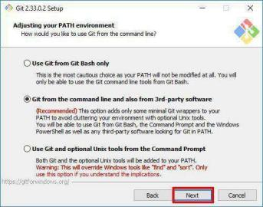

1. Choosing HTTPS Transport Backend

Select the HTTPS transport backend. Using the OpenSSL library is the default and recommended option.

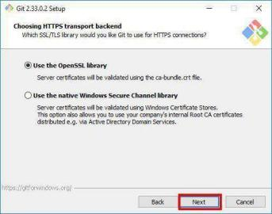

1. Configuring the Line Ending Conversions

Decide how Git will handle line endings. The default setting is suitable for most users.

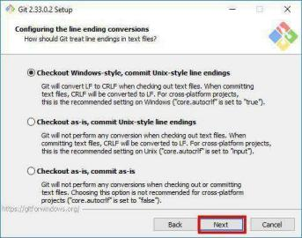

1. Configuring the Terminal Emulator

Choose the terminal emulator for Git Bash. The default MinTTY is recommended.

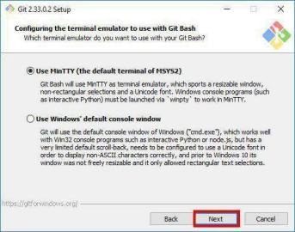

1. Configuring Extra Options

Select any additional options as needed. The defaults are generally appropriate.

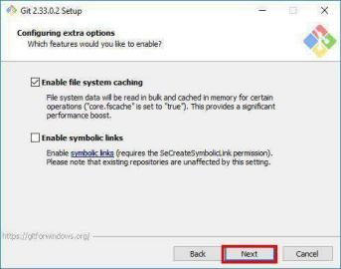

1. Installing Git

Click "Install" to begin the installation process.

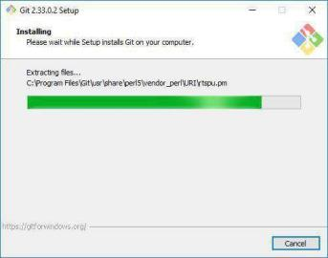

1. Completing the Installation

Once the installation is complete, git bash can be launched .

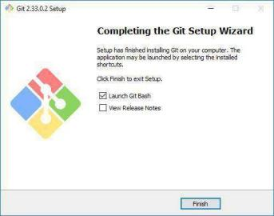

# Session-03 Introduction to GitHub and configuration into gitbash

During commiting gitbash asks for authentication

Example of creating a file and pushing into it

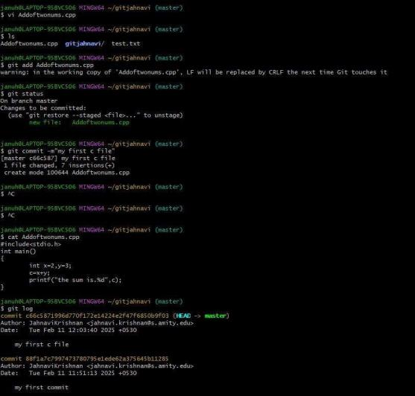

And before this, one must create a file and commit, push into repo , Then comes the git config:

1.The two most common git config commands are:

1. Set your usernamegit config --global user.name "Sumaya Iqbal"
2. Setting email

git config --global user.email "sumaya.iqbal@amity.edu"

Pushing and git remote, git log commands .

# Session-04 Creating branches and pushing into it (was a part of CA-1)

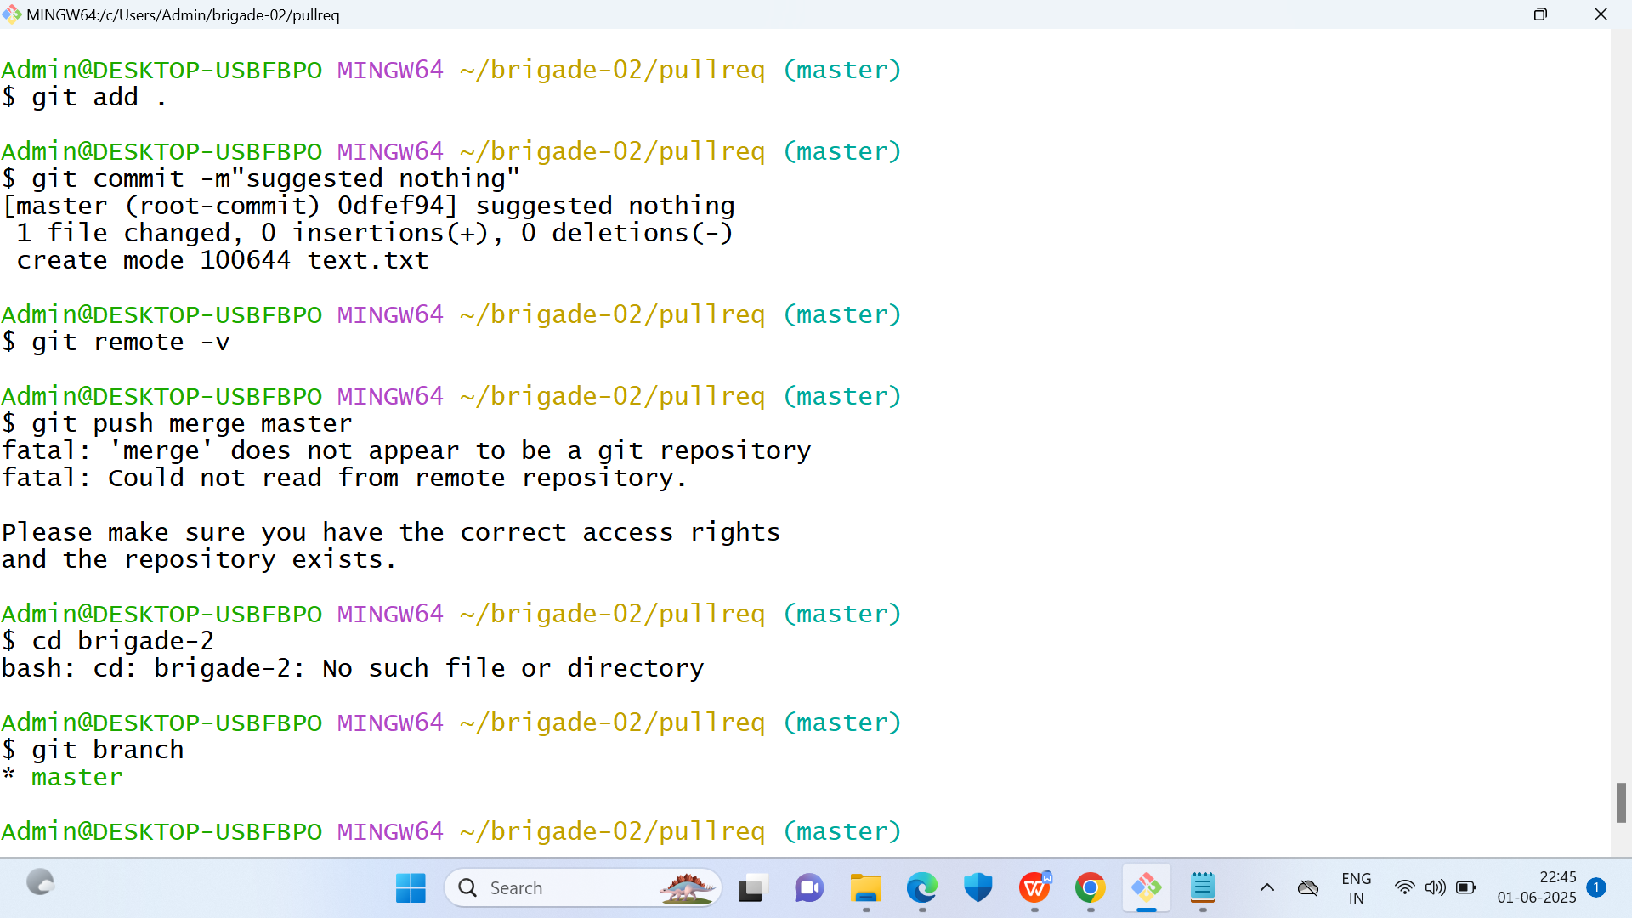

This session includes commands to check which branch one is on, to create a new branch and shift to those branches and compare branches using deff command

# Session-05: Merging two branches with and without conflicts and graphing all of them

# Session-06: Pull Requests and close in Github

Session-07: Github project

